Phase: 5 Building the IOT Flood Monitoring Early Warning System

# Project Objectives:

The primary objectives of this project are to:

1. **Enhance Public Safety**: To provide real-time flood monitoring and early warning to residents and authorities, reducing the risk of casualties and property damage during floods.
2. **Improve Emergency Response Coordination**: To enable faster and more efficient emergency response by providing accurate and timely data to relevant agencies.

# Deploy IOT Sensors:

1. **Sensor Selection:** Choose suitable water level sensors that are appropriate for the environment and expected water levels. Sensors can be ultrasonic, pressure- based, or float-type, depending on the specific requirements.
2. **Sensor Installation**: Securely install the sensors in the selected locations. The installation process may vary depending on the sensor type. Ensure they are well- protected against damage or vandalism.
3. **Power Supply**: Ensure a stable and reliable power supply for the sensors. Depending on the location, you might use solar panels, battery packs, or a combination of power sources to keep the sensors operational.
4. **Connectivity**: Set up the communication module on each sensor. This could be Wi-Fi, LoRa, or cellular connectivity, depending on the available infrastructure in the deployment area.
5. **Data Transmission**: Configure the sensors to transmit water level data to a centralized server or cloud platform. Implement data encryption and security measures to protect the data during transmission.
6. **Real-time Monitoring**: Implement real-time monitoring to confirm that sensors are transmitting data correctly. You can use diagnostic tools and monitoring software to track the data.
7. **Remote Access**: Ensure that you have remote access to the sensors and that you can reconfigure or troubleshoot them as needed.
8. **Security Measures:** Implement security measures to protect the sensors from physical and cyber threats. This may include enclosures, tamper detection, and authentication mechanisms.
9. **Data Validation**: Regularly validate the accuracy of the sensor data and recalibrate the sensors if necessary.
10. **Maintenance Plan**: Develop a maintenance plan to address routine sensor checks, cleanings, and repairs. This is crucial for long-term system reliability.

# Platform Development:

The system's platform includes both the hardware and software components.

* 1. **Sensor Nodes**: These are the physical sensors deployed in the field. They are equipped with microcontrollers, sensor modules, and communication components.
  2. **Gateway Devices**: These collect data from multiple sensor nodes and transmit it to the central server. Gateways often have more powerful processing capabilities and long-range communication.
  3. **Central Server**: This is the core of the system. It receives data from gateway devices and processes it in real-time. The server stores historical data, analyzes incoming data, and runs algorithms to detect flood conditions.
  4. **User Interface**: A web-based or mobile app interface for residents and authorities to access real-time data, alerts, and historical information.

# Code Implementation:

Implementing a flood monitoring and early warning system involves various components, including IoT sensors, data processing, and alerting. Below, I'll provide a simplified Python-based example that demonstrates the principles of such a system. Please keep in mind that a real-world system would be much more complex and require specialized hardware and extensive testing for accuracy and reliability.

# Requirements:

Python 3.x

Libraries: requests, random, and time (for simulation)

# Components:

**IoT Sensors Simulation**: We'll simulate IoT sensors that generate random water level data. In a real system, you'd use actual sensors.

**Data Processing:** This part analyzes the sensor data to detect potential floods**.**

**Alerting:** It sends alerts when flood conditions are met.

# Here's a simplified python code:

importtime importmachi neimportdht

# Define GPIO pins

TRIG_PIN = machine.Pin(2, machine.Pin.OUT) ECHO_PIN = machine.Pin(3, machine.Pin.IN) BUZZER_PIN = machine.Pin(4, machine.Pin.OUT)DHT_PIN = machine.Pin(5) LED_PIN = machine.Pin(6, machine.Pin.OUT)

defdistance_measurement():

# Trigger ultrasonic sensor TRIG_PIN.on()

time.sleep_us(10

)TRIG_PIN.off()

# Wait for echo to be HIGH (start time) whilenotECHO_PIN.value():

pass

pulse_start = time.ticks_us()

# Wait for echo to be LOW (end time)whileECHO_PIN.value():

pass

pulse_end = time.ticks_us()

# Calculate distance

pulse_duration = time.ticks_diff(pulse_end, pulse_start)

distance = pulse_duration / 58 # Speed of sound (343 m/s) divided by 2 returndistance

defread_dht_sensor():

d = dht.DHT22(DHT_PIN)

d.measure()

returnd.temperature(), d.humidity()

buzz_start_time = None # To track when the buzzer started whileTrue:

dist = distance_measurement() temp, humidity = read_dht_sensor()

# Check if the distance is less than a threshold (e.g., 50 cm) ifdist<50:

# Turn on the buzzer and LED BUZZER_PIN.on() LED_PIN.on()

status = "Flooding Detected"

buzz_start_time = time.ticks_ms()

elifbuzz_start_timeisnotNoneandtime.ticks_diff(time.ticks_ms(), buzz_start_time) >= 60000: # 1 minute

# Turn off the buzzer and LED after 1

minuteBUZZER_PIN.off() LED_PIN.off()

status = "No Flooding Detected"else:

status = "No Flooding Detected"

print(f"Distance: {dist:.2f} cm") print(f"Temperature: {temp:.2f}°C, Humidity:

{humidity:.2f}%")print("Status:", status) time.sleep(2)

# Diagram.json:

{

"version": 1,

"author": "Anonymous maker","editor": "wokwi", "parts": [

{

"type": "board-pi-pico-w", "id": "pico",

"top": -118.45,

"left": 32.35,

"attrs": { "env": "micropython-20231005-v1.21.0" }

},

{

"type": "wokwi-hc-sr04",

"id": "ultrasonic1",

"top": -238.5,

"left": -138.5,

"attrs": { "distance": "257" }

},

{

"type": "wokwi-buzzer",

"id": "bz1",

"top": -180,

"left": -228.6,

"attrs": { "volume": "0.1" }

},

{ "type": "wokwi-dht22", "id": "dht1", "top": -268.5, "left": 167.4, "attrs":

{} },

{ "type": "wokwi-led", "id": "led1", "top": -99.6, "left": -313, "attrs": { "color": "red" } },

{

"type": "wokwi-resistor", "id": "r1",

"top": 33.6,

"left": -317.35,

"rotate": 90,

"attrs": { "value": "300" }

}

],

"connections": [

[ "ultrasonic1:TRIG", "pico:GP2", "blue", [ "v0" ] ],

[ "ultrasonic1:ECHO", "pico:GP3", "cyan", [ "v0" ] ],

[ "ultrasonic1:GND", "pico:GND.1", "black", [ "v0" ] ],

[ "bz1:2", "pico:GP4", "red", [ "v0" ] ],

[ "bz1:1", "pico:GND.2", "black", [ "v0" ] ],

[ "dht1:GND", "pico:GND.8", "black", [ "v0" ] ],

[ "dht1:SDA", "pico:GP5", "limegreen", [ "v0" ] ],

[ "ultrasonic1:VCC", "pico:3V3_EN", "red", [ "v0" ] ],

[ "dht1:VCC", "pico:3V3_EN", "orange", [ "v0" ] ],

[ "led1:C", "pico:GP6", "yellow", [ "v0" ] ],

[ "led1:A", "r1:1", "magenta", [ "v0" ] ],

[ "r1:2", "pico:3V3", "magenta", [ "h0" ] ]

"dependencies": {}

}

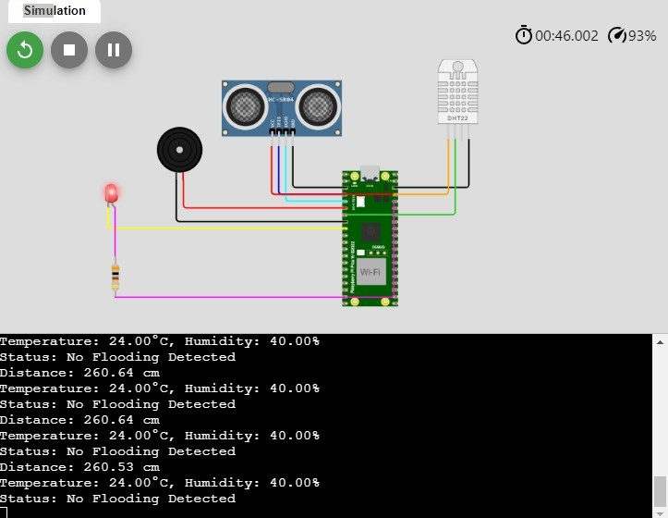

**Tocreateaplatformthatdisplaysreal-timewaterleveldata andflood warnings. HTML**

**Fmes.html**

<!DOCTYPEhtml>

<html>

<head>

<metacharset="UTF-8">

<title>Real-TimeWaterLevelData&FloodWarnings</title>

<linkrel="stylesheet"type="text/css"href="flood.css">

</head>

<body>

<h1>Floodmonitoringsystemmodel</h1>

<divclass="hed">

<divclass="header">

<h1>Real-TimeWaterLevelData&FloodWarnings</h1>

</div>

<divclass="content">

<divclass="water-level">

<h2>CurrentWaterLevel:<spanid="waterLevel">loading...</span></h2>

</div>

<divclass="flood-warning">

<h2>FloodWarningdetection:<span

id="floodWarning">loading...</span></h2>

</div>

</div>

<scriptsrc="flood.js"></script>

</div>

</body>

</html>

**CSS:**

**flood.css**

body{

font-family:Arial,sans-serif; background-color: #f0f0f0; margin: 110px; padding:10px;

}

.hed{

border-style:solid;

}

.header{

background-color:#d84155; color: white;

text-align:center;

padding: 20px;

}

.content { margin:20px; text- align:center;

}

.water-level,.flood-warning{

background-color:rgba(18,179,207,0.486); padding: 10px; margin:10px;

border:1pxsolid#ccc;

}

**JS:**

**flood.js** constWaterLevelData=()=>(Math.random()*10).toFixed(2); const

FloodWarningData = () => Math.random() > 0.7;

functionupdateData(){

const waterLevelElement = document.getElementById("waterLevel"); constfloodWarningElement = document.getElementById("floodWarning");

constwaterLevel=WaterLevelData(); constisFloodWarning=FloodWarningData();

waterLevelElement.textContent = waterLevel + " meters"; floodWarningElement.textContent=isFloodWarning?"Yes":"No"; floodWarningElement.style.color=isFloodWarning?"red":"green";

}

setInterval(updateData,5000);

updateData();

Web Page for Real-Time water level data and Flood Warning:

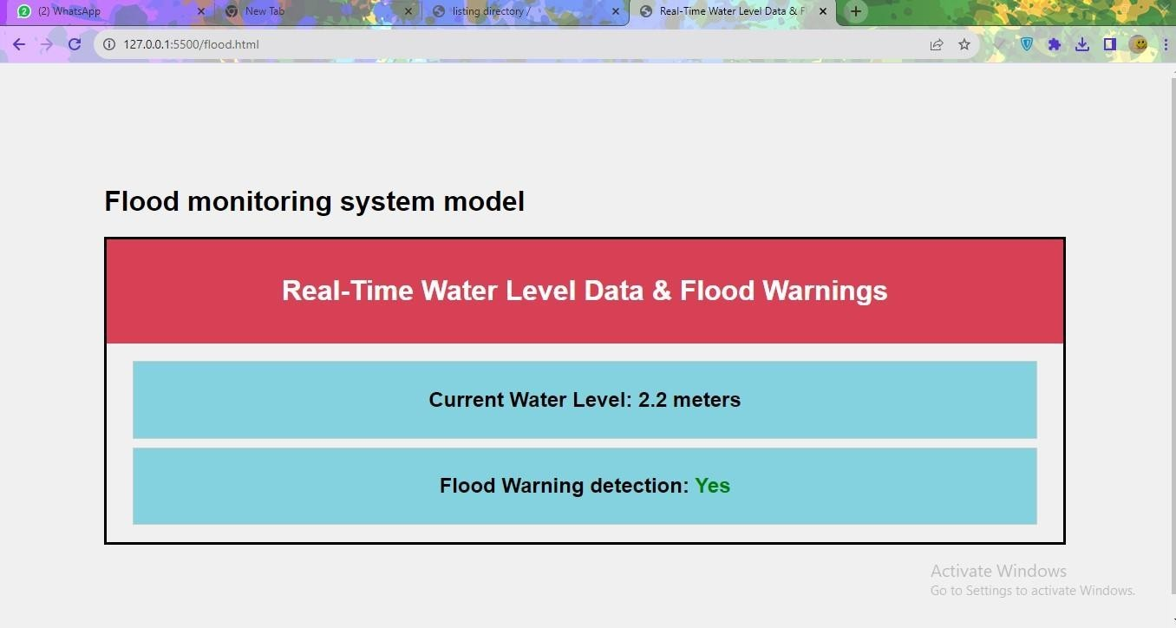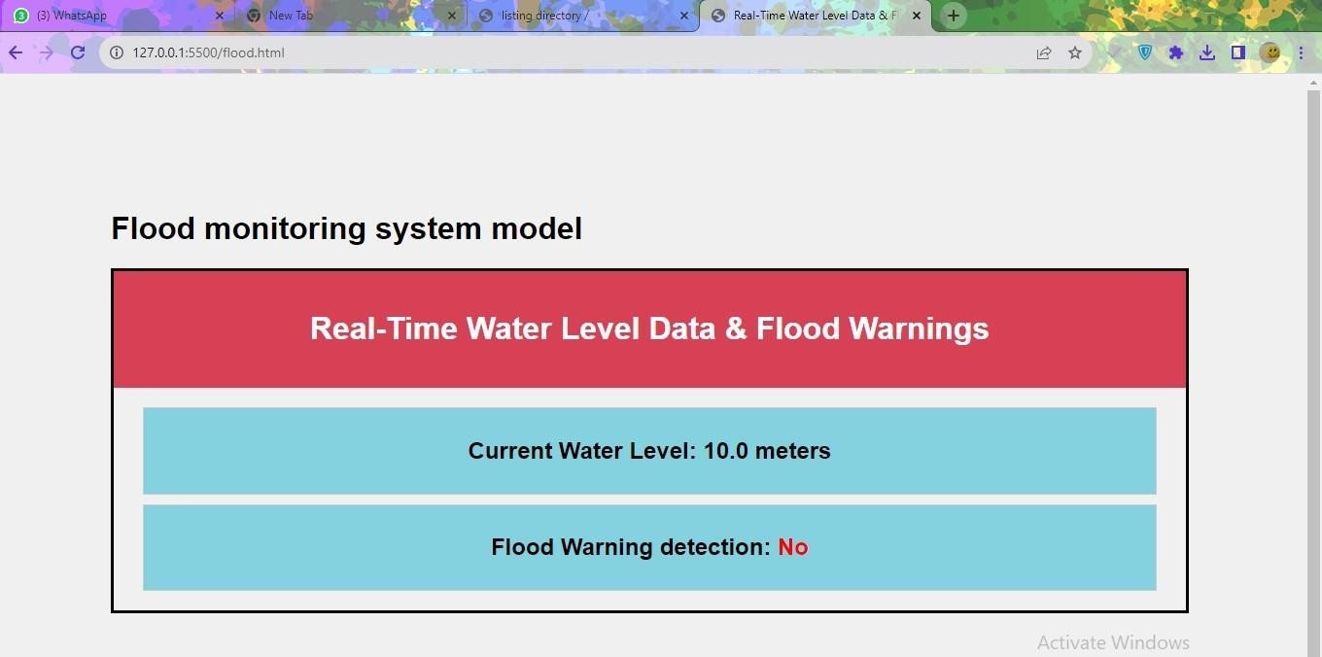

# Explain how the real-time flood monitoring and early warning system canenhance public safety and emergency response coordination:

A real-time flood monitoring and early warning system is a critical tool for enhancing public safety and emergency response coordination in areas prone to flooding. It leverages technology and data to provide timely information about potential flood events and their impacts. Here's how such a system can enhance public safety and emergency response coordination:

# Early Detection and Alerting:

* + Flood monitoring systems use various sensors, such as river gauges, rainfall monitors, and weather radars, to detect changes in water levels and precipitation patterns.
  + When abnormal conditions are detected, the system can issue early warnings, which are often communicated through various channels, including mobile apps, text messages, sirens, and social media.
  + Early warnings provide individuals and communities with ample time to prepare for the impending flood, which can significantly reduce the risk to human life.

# Evacuation Planning:

* + Timely flood warnings allow local authorities to plan and coordinate evacuations if necessary. They can identify high-risk areas and mobilize resources and personnel to ensure a smooth and efficient evacuation process.
  + Residents can receive information about evacuation routes, shelter locations, and safety guidelines well in advance, increasing their chances of safely leaving flood-prone areas.

# Resource Allocation:

* + Real-time data from flood monitoring systems help emergency responders allocate resources effectively. They can identify the areas most at risk and ensure that rescue teams, equipment, and supplies are positioned strategically.
  + Efficient resource allocation minimizes response time and maximizes the ability to help those affected by the flood.

# Reduced Response Time:

* + With real-time information on the progression of a flood event, emergency responders can act swiftly and effectively. This reduces response time and improves their ability to save lives and property.
  + Coordinated responses can be initiated as soon as the first warnings are issued, preventing delays in getting assistance to those in need.

# Public Awareness and Education:

* + Flood monitoring and early warning systems raise public awareness about the risks associated with flooding. This knowledge empowers individuals and communities to take proactive measures to protect themselves and their property**.**
  + Educational campaigns can provide information on flood preparedness, including the importance of having emergency kits, evacuation plans, and flood insurance.

# Data-Driven Decision-Making:

* + Flood monitoring systems collect and provide valuable data that can inform decision- making at various levels of government and emergency management.
  + Authorities can make informed decisions about land use, infrastructure development, and floodplain management, helping to mitigate the long-term impact of floods.

# Post-Flood Recovery:

* + After a flood event, the system can continue to provide valuable data for recovery efforts. It helps assess the extent of damage and prioritize areas in need of assistance.
  + Coordinated response and recovery efforts are critical for restoring affected communities and infrastructure.